Social and Professional Issues

Tutorial 6

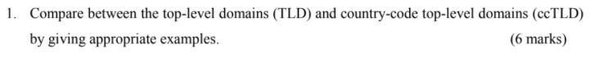

|  |  |
| --- | --- |
| **Top-level domains (TLD)** | **Country-code top-level domains(ccTLD)** |
| The top-level domain, also referred to as TLD and it is a fully qualified domain name, the suffix or extension attached to Internet domain names. | A country code top-level domains are generally used or reserved for a country, sovereign state, or dependent territory identified with a country code |
| Top-level domains also Is the rightmost part of a domain name.  Example: .com  .org  .edu  .net  .co  .biz | ccTLDs are always made up of a two-letter code that is assigned to every country and target specific region.  Example: .my .jp .cn .th .sg .hk |
| For example, the **.name** TLD is reserved for individuals, and  **.edu** is reserved for educational entities. | ccTLDs that can be registered by anyone — .co representing Colombia, for example, have no residency requirements at all.  Others:  **.ca :** canada  **.ru :** Russia |

|  |
| --- |
| Sample Answer |

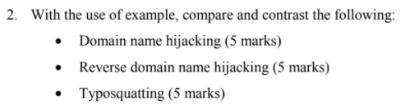

Domain name hijacking

- Registration of well known names for the purposes of selling them for profit, or to redirect traffic looking for other organizations to one's own site.

- Eg: Someone plans in advance that “www.tarc.com.my” purchases the domain name. Then if the TARCollage desires the web address they have to pay a lot of money for it.

Reverse domain name hijacking

- Attempts to use legal processes/means to grab a legitimate name that an organization simply wished it had the foresight to register first has become known as and is arguably as big a problem as domain-name hijacking

- Eg: Zoe purchased the domain name “www.tarc.com.my”, not to make a profit upon sale. The TARCollege sues Zoe and wants money and want back the “[www.tarc.com.my](http://www.tarc.com.my) through initiate a legal prosecution against Zoe - reverse domain name hijacking .

Typosquatting

- Also called URL hijacking, or a fake URL, is a form of cybersquatting, and possibly brandjacking which relies on mistakes such as typos made by Internet users when inputting a website address into a web browser. Should a user accidentally enter an incorrect website address (similar spelling website), they may be led to any other URL.

- Eg: The imposter purchased a domain name called “www.maybanku2.com.my” which is similar with maybank’s official website “www.maybank2u.com”, if someone accidentally typo and enter to the unofficial fake website, those bank information might be stolen.

|  |
| --- |
| Sample Answer |

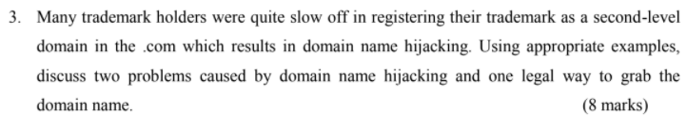

Problems :

1. Financial Damage

· Companies that rely on their website for business may lose much of their revenue when they lose control of their domain as the customers will not be able to contact them through the websites and take the business elsewhere.

· E.g : Proton car customers will be unable to check the cars online and may search for cars from other companies.

2. Losing the best domain name

· Companies unable to register domain name which best represents their company name as it is already taken by someone else.

· E.g : The Proton car company is unable to register www.proton.com as their domain name as it is already taken by Joe Proton.

Legal way to grab domain name:

* Reverse domain name hijacking

· Attempts to use legal processes/means to grab a legitimate name that an organization simply wished it had the foresight to register first. This is considered a legal way to counter the practices of domain name hijacking.

· E.g : Joe Proton buys the domain name, not to make a profit upon sale, but rather, so that his family could use it for pictures and a blog. The proton car company sues Joe and wants money and want the domain name back.

|  |
| --- |
| Sample Answer |



ICANN stands for Internet Corporation for Assigned Names and Numbers, it is responsible for coordinating the management of the technical elements of the DNS to ensure universal resolvability so that all users of the Internet can find all valid addresses. It does this by overseeing the distribution of unique technical identifiers used in the Internet’s operations, and delegation of Top-Level Domain names ( such as .com, .info, etc.).

Other issues of concern to Internet users, such as the rules for financial transactions, Internet content control, unsolicited commercial email (spam), and data protection are outside the range of ICANN’s mission of technical coordination.

Other roles:

-draft , finalized and enforce Internet governance related rules/policy/terms and conditions.

-launch new TLD into the market, e.g. .boutique, .travel, .museum….etc

-manage the Internet Protocol (IP) address space for IPv4 , IPv6

-assignment internet address block to regional/country internet registries

|  |
| --- |
| Sample Answer |



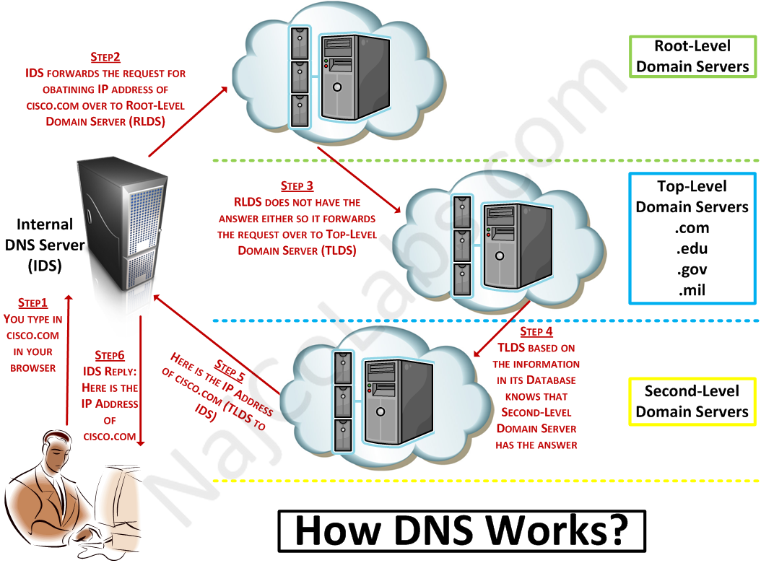

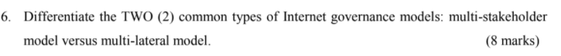

|  |  |
| --- | --- |
| **multi-stakeholder model** | **multi-lateral model** |
| -Implies consultation with various governments, corporations, citizens and etc while deciding on policy issues on internet governance and net neutrality. | -Implies consultation between governments only. |
| -Enables democratic discussions and policy making. It takes time to get various viewpoints and efforts to accommodate multiple preferences. | -Provides for an equal voice and vote in decision making. It doesn’t have a comprehensive policy making strategy. Decisions are sometimes based on politics between the countries rather than interests alone. |

Internet Governance Model ---> Multistakeholder model Vs. multilateral model

**Multi-stakeholder Model:**

Decision maker: a **multistakeholder committee** to make up the following parties: government representatives, NGO (non-government organization), private sector representatives, civil society representatives, public/web surfer representatives, education sector representatives, etc….. To meet up, draft, discuss, debate and finalized the internet governance policy and enforcement.

Countries: France, USA, south korea, etc

- Low Degree of internet censorship & low degree secret surveillance upon the content/site that you are assessing through while surfing the internet.

- High Degree of transparency in the decision making of Internet governance stuff/policy making process

**Multi-Lateral Model**

Decision maker: individual country government or discussion between 2 country government in order to draft, discuss and finalized the internet governance policy and enforcement.

Countries involved: conservation countries like China, North Korea,

- High Degree of internet censorship control & high degree secret surveillance upon the content/site that you are assessing through while surfing the internet.

- Low Degree of transparency in the decision making of Internet governance stuff/policy making process

|  |
| --- |
| Sample Answer |